Session 12

- Given two 2x2 matrices representing the number of likes and comments on two Instagram posts over two days, write Python code to multiply them and display the resulting matrix.
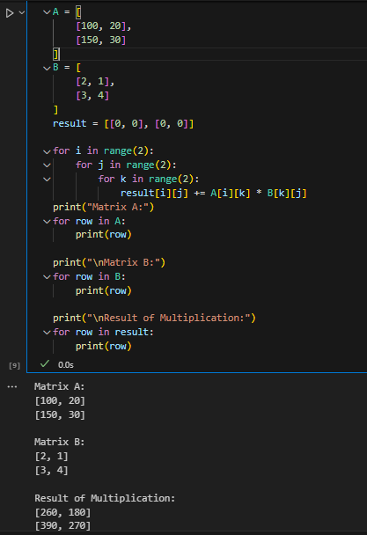

- Create a simple Python function linear_regression_predict(x, m, c) that takes an input value x, slope m, and intercept c, and returns the predicted output y for a linear regression equation y = mx + c.
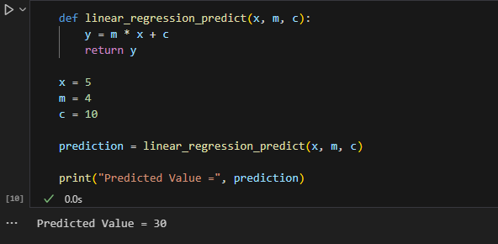

- Imagine you are predicting the delivery time for Zomato orders based on distance. Given three distances (2km, 5km, 8km) and a linear regression equation y = 4x + 10 (where y is minutes), use your function from the previous task to calculate the predicted delivery time for each distance.
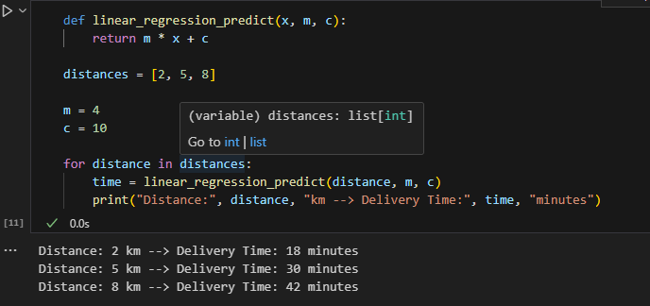

- Explain in your own words what the slope and intercept represent in the context of Flipkart's product price prediction (e.g., predicting price based on product rating). Write 2-3 sentences for each term.

Slope (m)
The slope represents how much the predicted product price changes when the product rating increases by one unit. A positive slope means higher ratings usually lead to higher predicted prices.

Intercept (c)
The intercept is the predicted price when the product rating is zero. It is the starting value of the linear regression equation before the effect of the rating is added.

5.Use ChatGPT to ask: 'How does matrix multiplication help in training a machine learning model like Spotify's song recommendation system?' Summarize the answer in your own words in 3-4 sentences.

Matrix multiplication helps machine learning models process large amounts of user and song data efficiently. It combines user preferences with song features to calculate recommendation scores. During training, matrix multiplication is used repeatedly to update model parameters and improve prediction accuracy. This allows Spotify to recommend songs that best match each user's listening habits.

